**NEURAL NETWORKING**

**Basic Information**

* **Convolution neural network:** Neural network used for **image processing**.
* **Long short-term memory network:** Neural network used for **speech recognition**.

**Plain Vanilla**

* Also known as **multi-layered perceptron**.
* **Neuron:** A container holding number in **range [0,1]**.
* **Activation:** Value of the number the neuron is holding.
* Activation in convolution neural networks represents the **grayscale** of a pixel from image.

**Plain Vanilla Example**

* **Step 1:** Assigning activation to each **pixel/neuron**:-

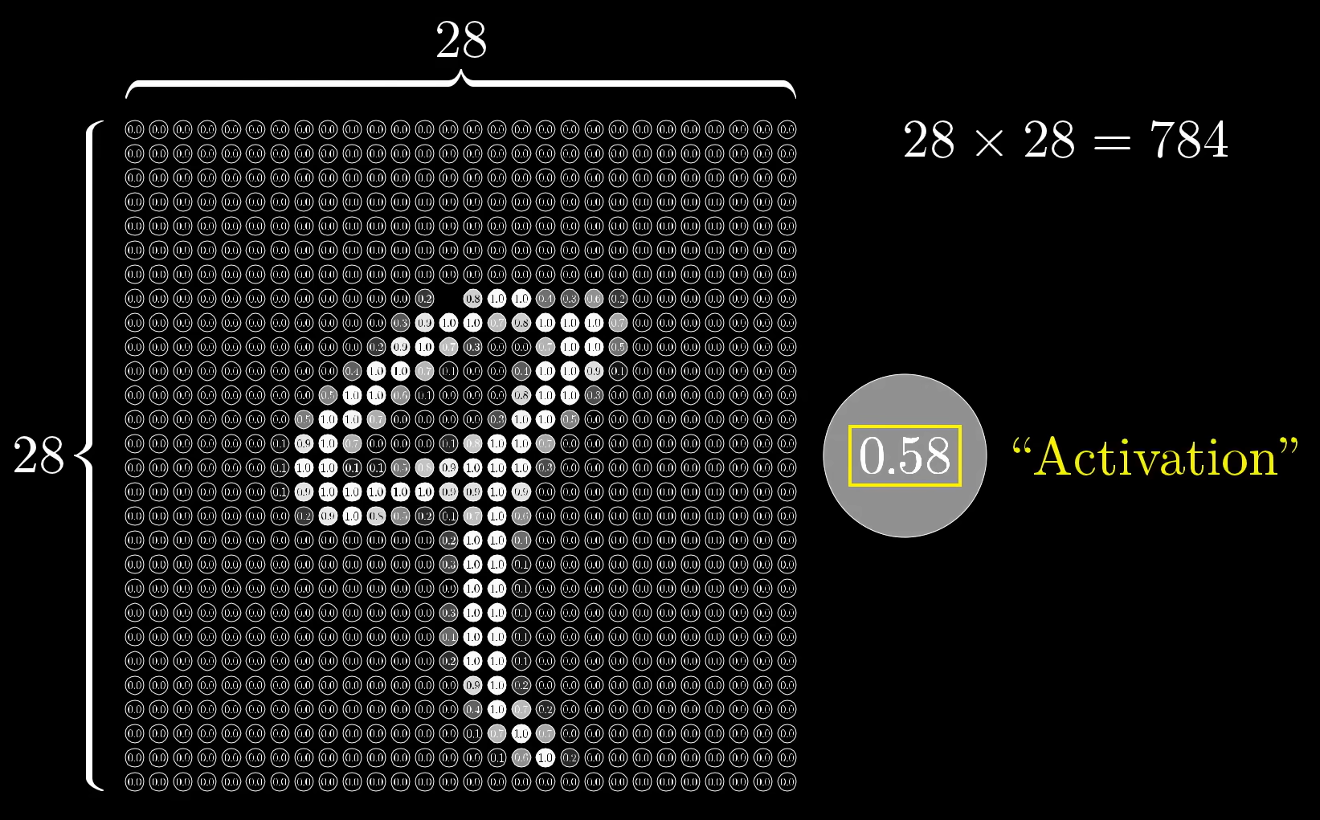

* **Step 2:** Drawing multiple layers of neurons:-

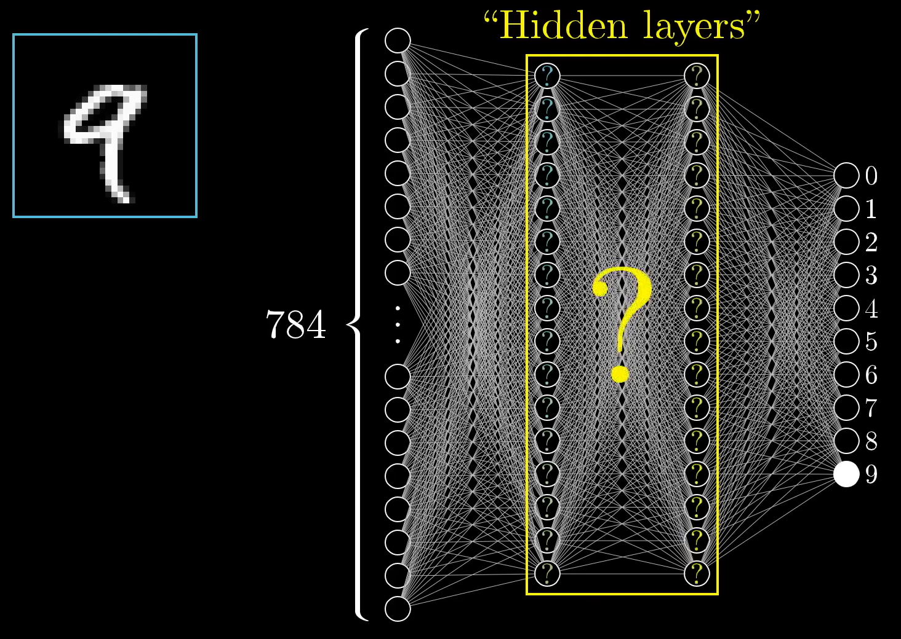

* **Step 3:** Patterns recognised in images (might be processed one of the layers):-

